Technical document
Objective
Build a C# console application that:
- Spawns 10 threads
- Each thread performs 10 iterations (total 100 units of work).
- Each unit of work is assigned a unique sequence number via Interlocked.Increment (1...100).
- Uses a thread-safe BlockingCollection<WorkItem> for producer–consumer communication.
- A single consumer drains the queue and writes to a file:
- LineNumber (sequential 1...100)
- Producer ThreadId
- Message timestamp
- Program exits cleanly after all lines are written.

Non-Functional
- Thread-safe design
- Deterministic output ordering via a single writer and buffering.
- Cross-platform (Windows/Linux/macOS) via .NET.
- One consumer thread that reads from the queue and writes to a text file.

- If the BlockingCollection is bounded and currently full, add blocks until space is available (backpressure).
- If cancellation is requested while blocked, it throws OperationCanceledException.
- This method runs on a producer thread.
- It creates 10*10 lines and pushes them into a thread-safe queue.
- It cooperates with cancellation and propagates failures to stop the entire system safely.

Architecture & Concurrency Model
Components
- Global Sequence Generator: Interlocked.Increment(ref _seq) ensures unique, strictly increasing IDs across threads.
- Shared Collection: BlockingCollection<(int Seq, string ThreadName, int Iteration)> backed by ConcurrentQueue<T>.
- Workers (10 Threads): Each thread generates 10 items and adds them to the BlockingCollection.
- Writer (Single Consumer Task): Dequeues items and writes them to a file in exact sequence.
Rationale
- BlockingCollection provides a thread-safe producer–consumer pattern out-of-the-box.
- A single writer prevents file write interleaving and avoids locking on StreamWriter.
- Buffering for order eliminates non-deterministic output ordering without stalling workers.

Data Flow:
Creates a cancellation token to cancel work cooperatively.
Creates a thread-safe shared collection (BlockingCollection) with a bounded capacity (provided by boundedCapacity).
Starts a single consumer thread to write to the file.
- Having one writer avoids file lock/contention issues.
- Spawns numberOfThreads producer threads (intended to be 10).
- Each producer runs ProducerLoop, enqueuing linesPerThread items (intended to be 10).
- Signals no more items will be added (if not already signaled due to cancellation).
- Waits for the consumer to finish draining and exit.
Uses Interlocked.Increment(ref lineNumber) to assign a sequential line number in a thread-safe way.
Catches cancellation and I/O errors to exit gracefully.

Directive structure:
OlympusAssignment
- OlympusAssignment /
- ├─ Program.cs
- ├─ log
  - └─ out.txt
- └─ OlympusAssignment.csproj

Output :

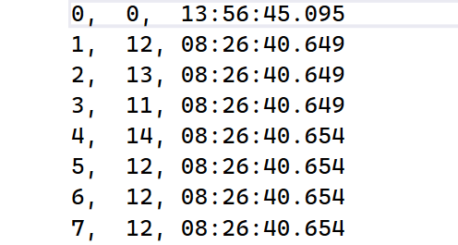

Till 100
- The first column is the sequential line number assigned by the consumer.
- ThreadId is the actual producer’s managed thread ID.
- DateTime.UtcNow: timestamp at creation.

